Screenshots of Hue

1. select count(churn),tenure from telco_upx.telco where churn == 'Yes' group by tenure;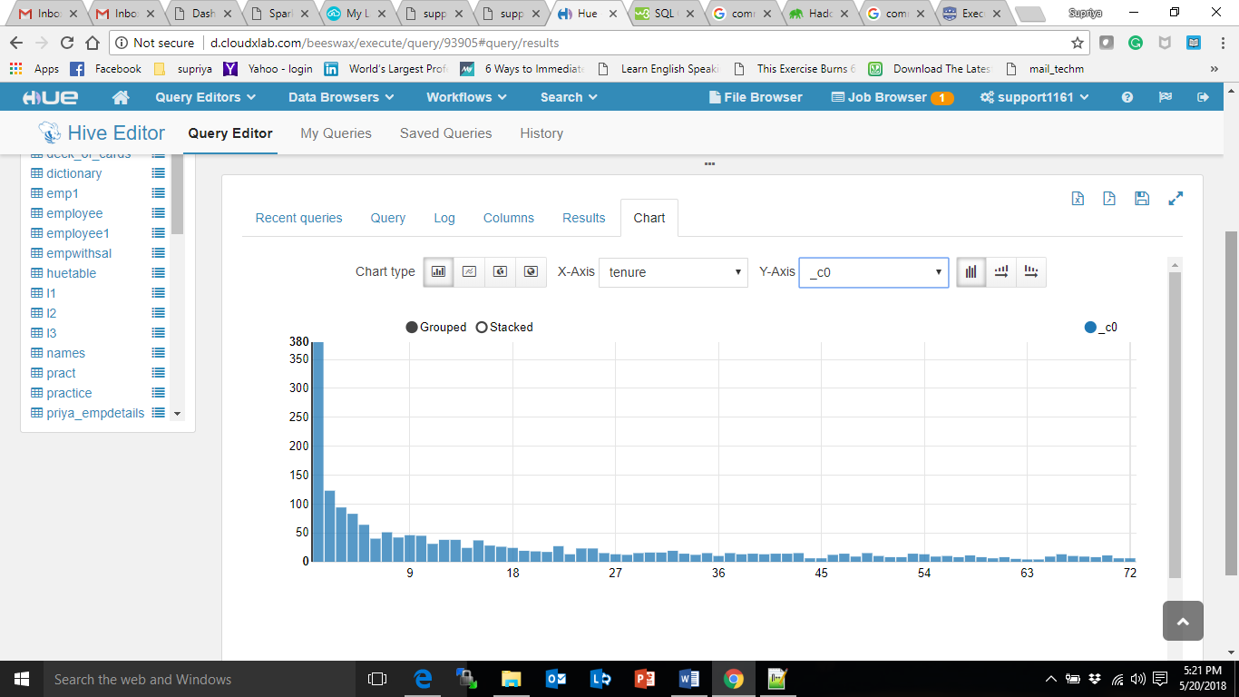
2. select count(churn),onlinesecurity from telco_upx.telco where churn == 'Yes' group by onlinesecurity;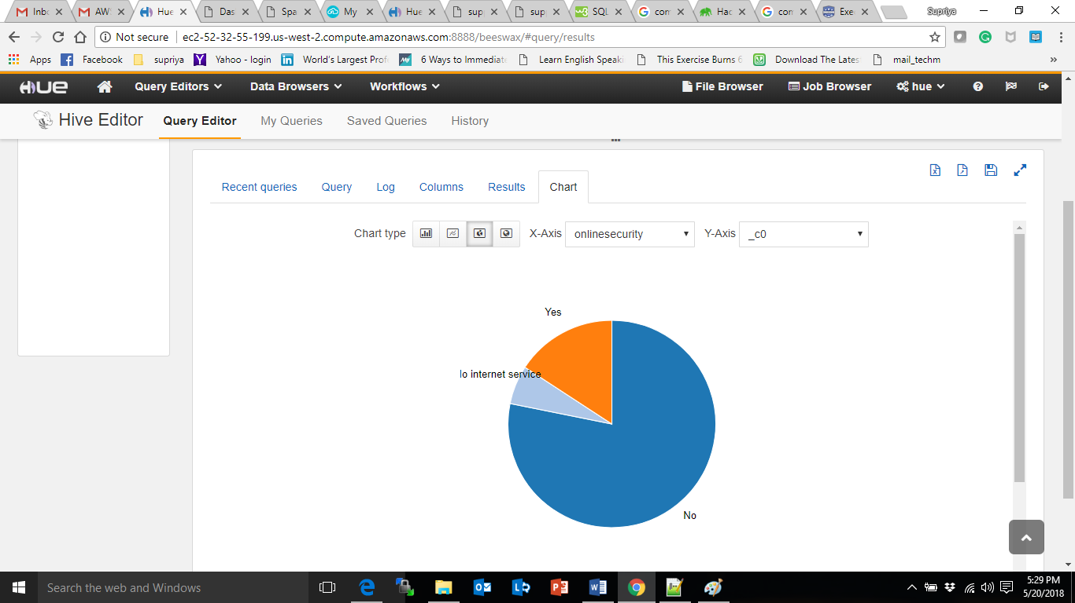
3. select count(churn),seniorcitizen from telco_upx.telco where churn == 'Yes' group by seniorcitizen;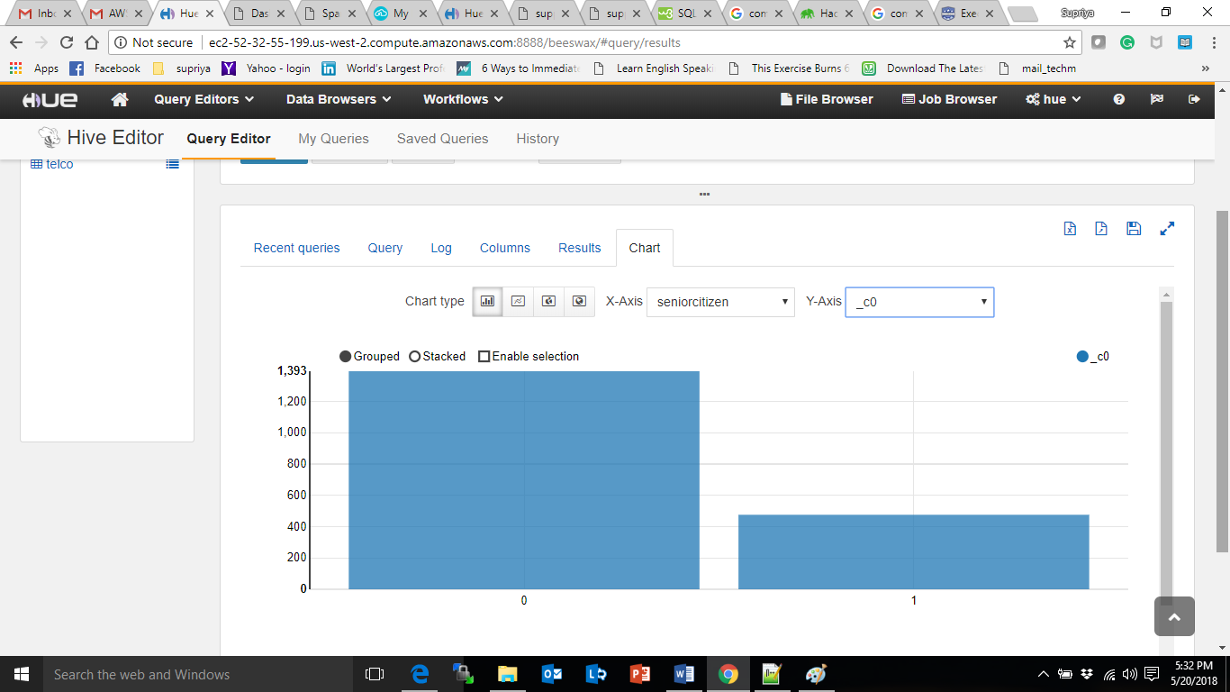
4. select count(churn),gender from telco_upx.telco where churn == 'Yes' group by gender;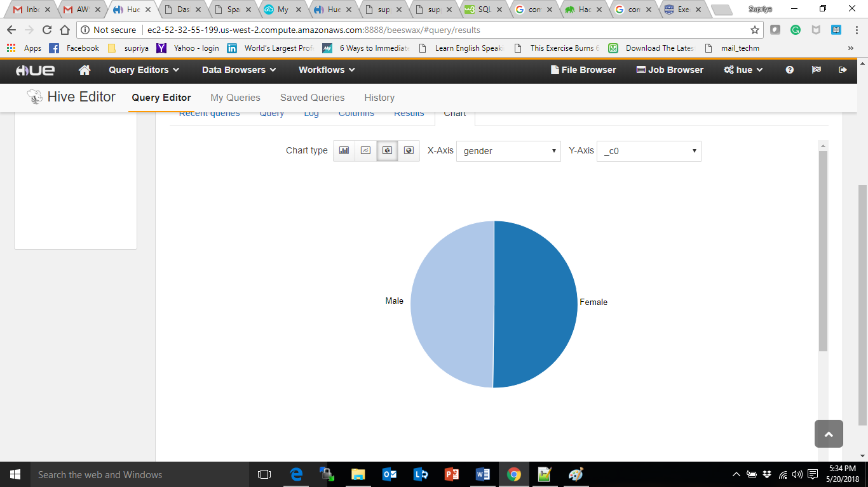
5. select count(churn),churn from telco_upx.telco group by churn;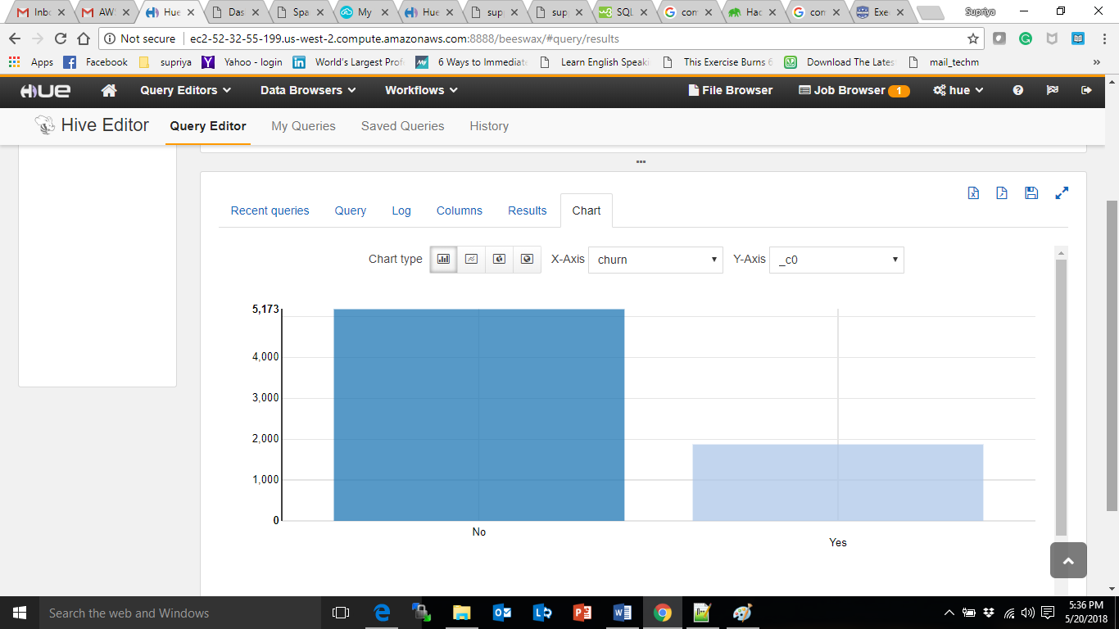
6. select round(tenure/12) as year,monthlycharges,

case when round(tenure/12) = 1 then 0.9*monthlycharges

when round(tenure/12) = 2 then 0.8*monthlycharges

when round(tenure/12) = 3 then 0.7*monthlycharges

when round(tenure/12) = 4 then 0.6*monthlycharges

when round(tenure/12) = 5 then 0.5*monthlycharges

when round(tenure/12) >= 6 then 0.4*monthlycharges

else monthlycharges end as amount_to_be_paid

from telco_upx.telco;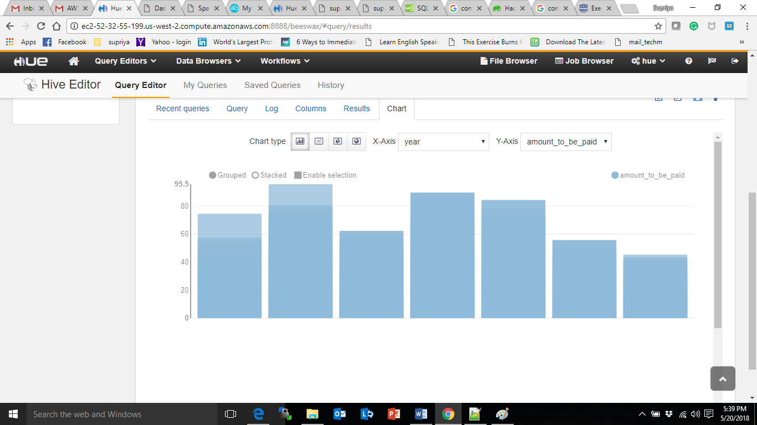

1. select round(tenure/12) as year,count(round(tenure/12)) from telco_upx.telco group by round(tenure/12);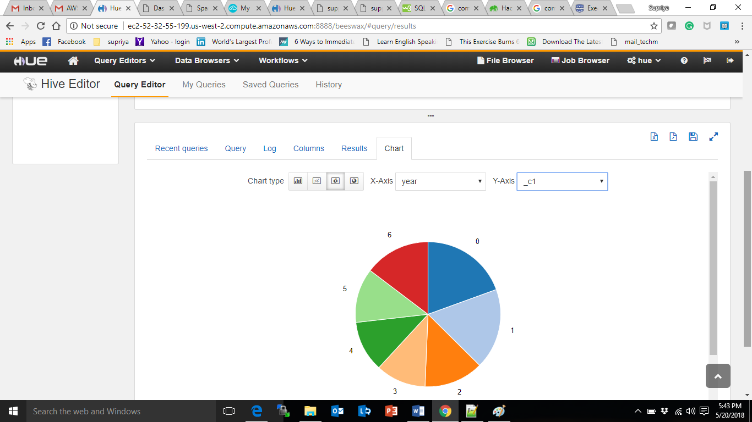
2. select paperlessbilling,count(paperlessbilling) from telco_upx.telco group by paperlessbilling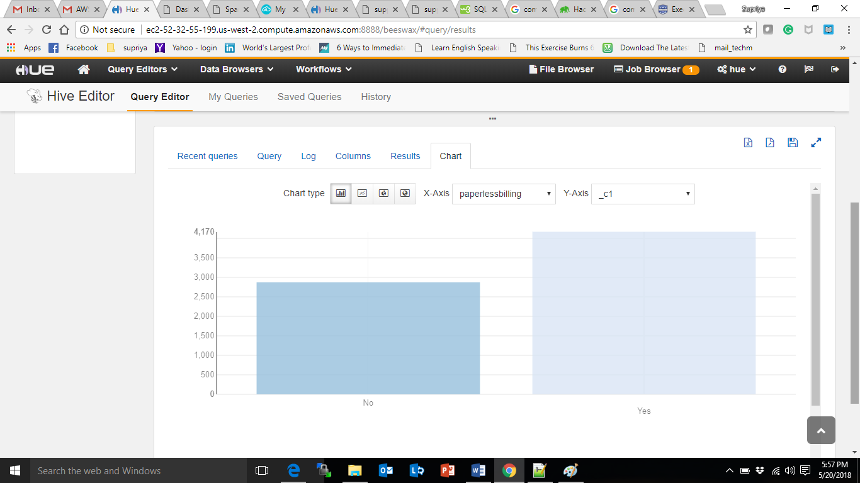
3. select COUNT(internetservice),internetservice from telco_upx.telco where seniorcitizen = 1 group by internetservice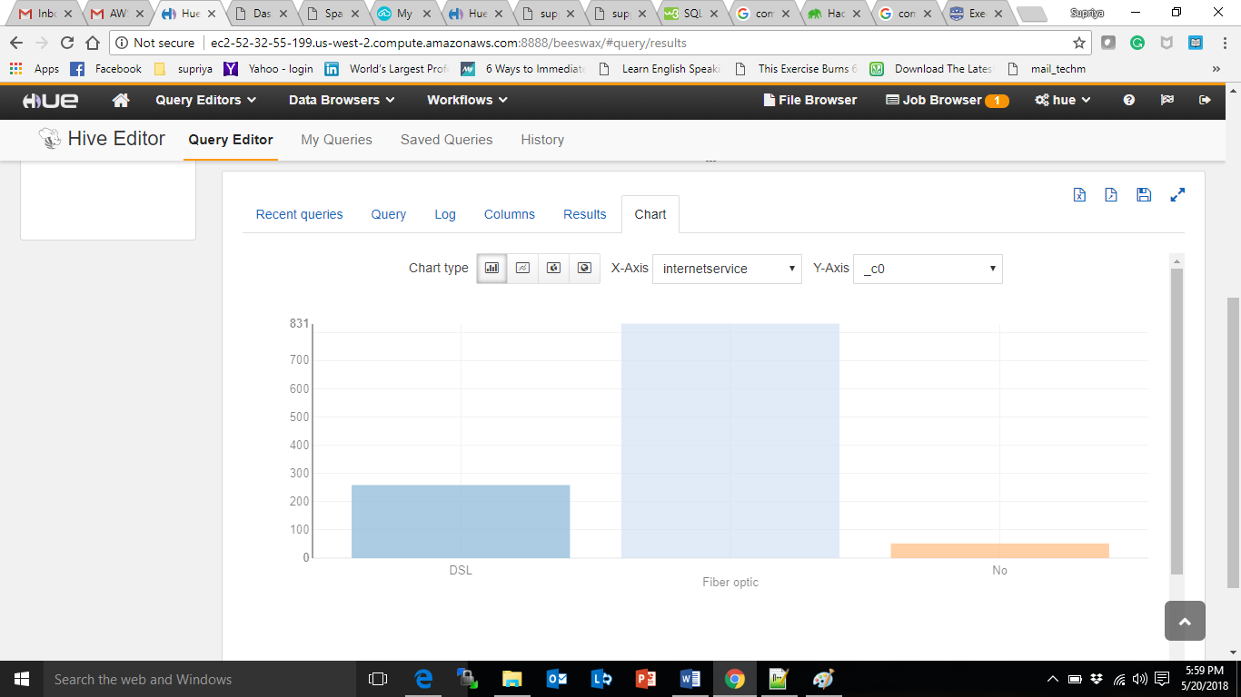
4. select gender,count(streamingtv) from telco_upx.telco group by gender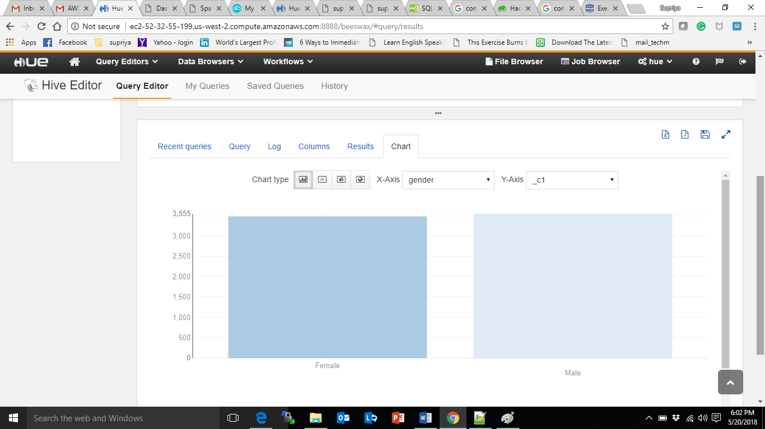

select gender,count(streamingmovies) from telco_upx.telco group by gender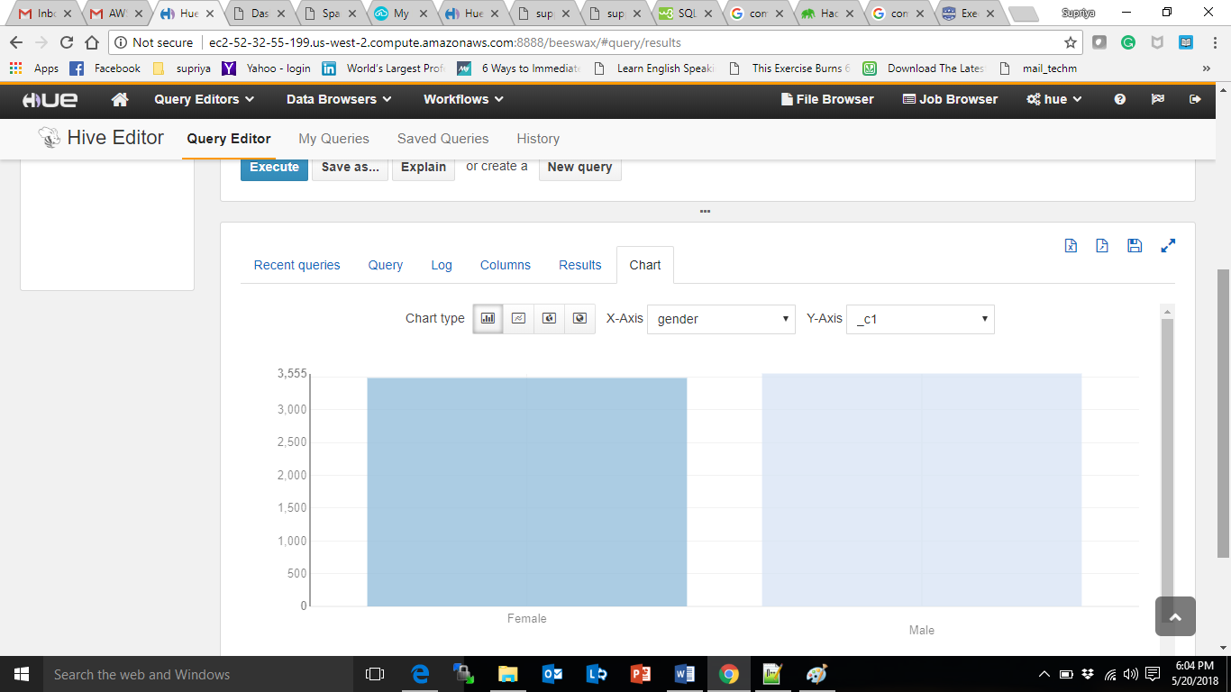

1. select count(paymentmethod),paymentmethod from telco_upx.telco group by paymentmethod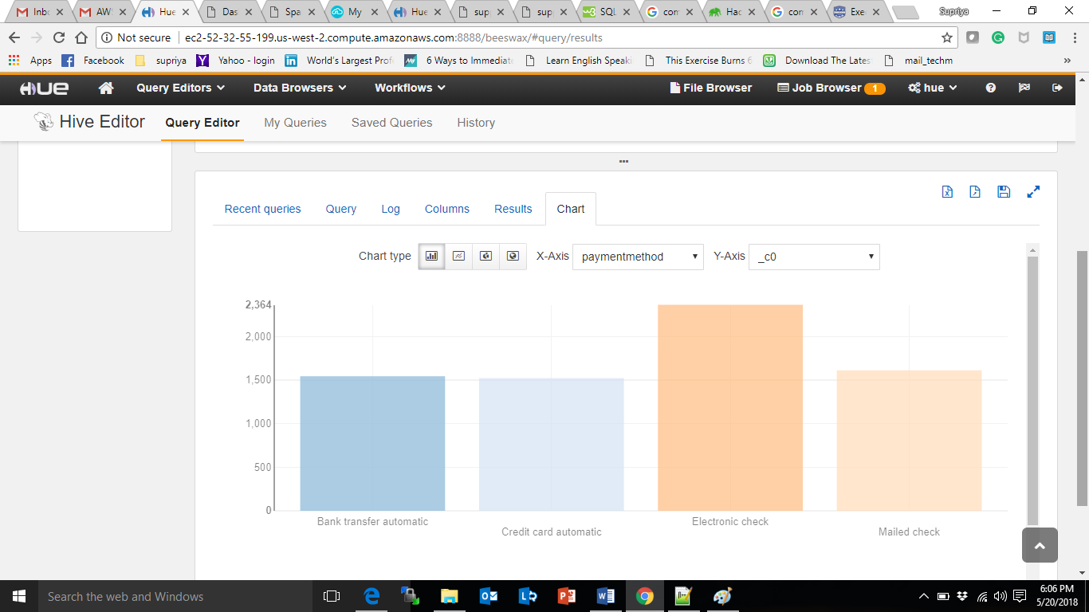
2. select gender,paymentmethod,count(paymentmethod) from telco_upx.telco group by gender,paymentmethod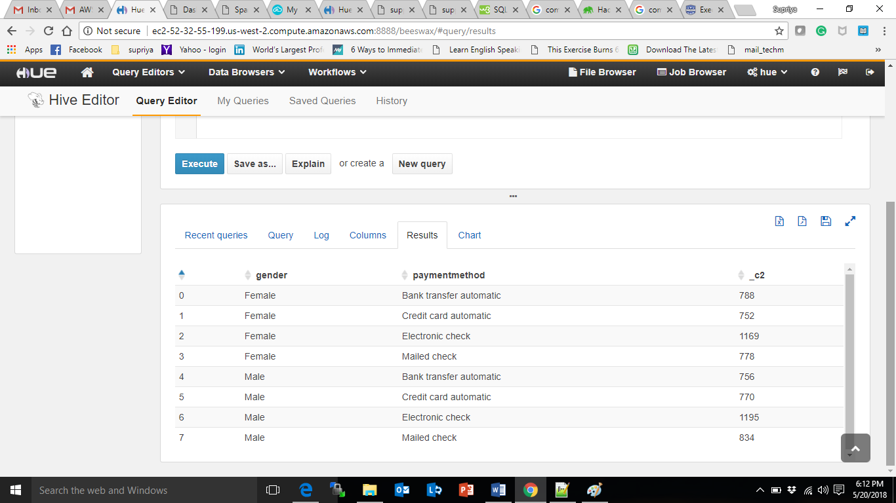
3. select count(techsupport) from telco where techsupport == 'Yes'